1. Grade Checker
marks = int(input("Enter The Marks: \n"))

if marks >= 90:
grade = 'A'
elif marks >=80:
grade = 'B'
elif marks >=70:
grade = 'C'
elif marks >=60:
grade = 'D'
else:
grade = 'F'

print("Your Grade is: " + grade)
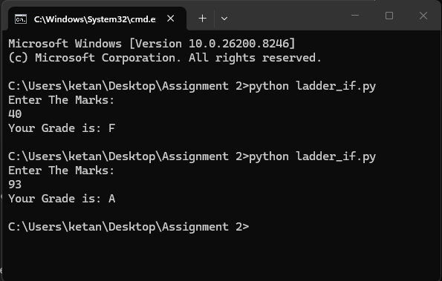
Explanation
- The program takes the student's marks as input.
- if, elif, and else conditions are used to check the score range.
- Based on the score, the appropriate grade is displayed.

2. Student Grades Dictionary Program
students = {}

while True:
print("\nStudent Grade Menu")
print("1. Add Student")
print("2. Update Grade")
print("3. Display All Grades")
print("4. Exit")

choice = input("Enter your choice: ")

if choice == '1':
name = input("Enter student name: ")
grade = input("Enter grade: ")
students[name] = grade
print("Student added successfully.")

elif choice == '2':
name = input("Enter student name to update: ")

if name in students:
new_grade = input("Enter new grade: ")
students[name] = new_grade
print("Grade updated successfully.")
else:
print("Student not found.")

elif choice == '3':
print("\nStudent Grades:")

for name, grade in students.items():
print(name, ":", grade)

elif choice == '4':
print("Exiting program...")
break

else:
print("Invalid choice.")
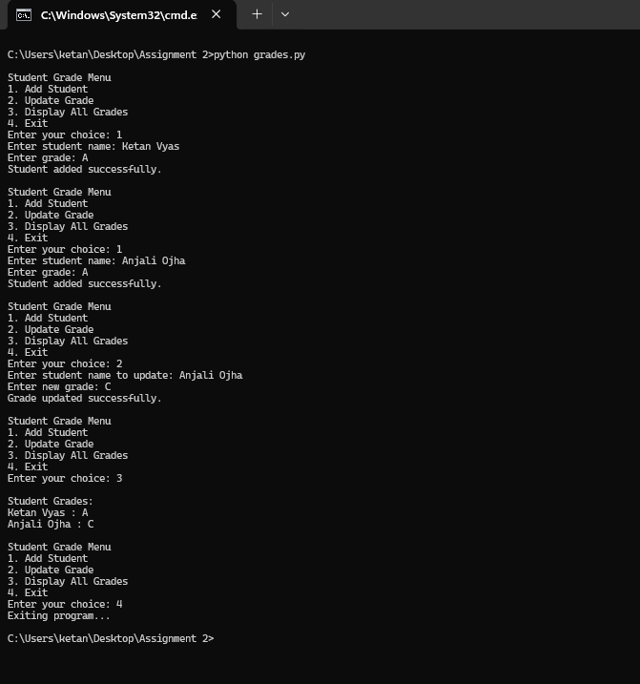
Explanation
- A dictionary named students is used to store student names and grades.
- if-else statements handle menu operations.
- students[name] = grade adds or updates values.
- for loop is used to display all records.

3. Write to a File
file = open("sample_file.txt", "w")

file.write("Hello! This is my first file handling program in Python.\n")
file.write("Python makes file operations easy.")

file.close()

print("Content written successfully.")
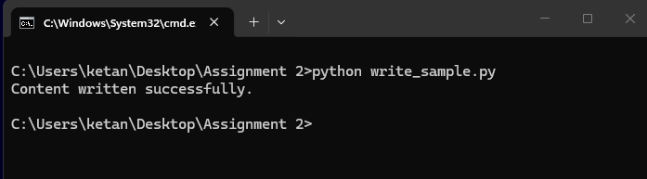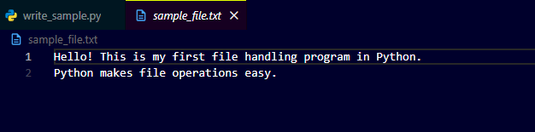
Explanation
- open() function is used with "w" mode to create or write into a file.
- write() function adds content to the file.
- close() is used to save and close the file.
4. Read from a File
file = open("sample_file.txt", "r")

content = file.read()

print("File Content:")
print(content)

file.close()
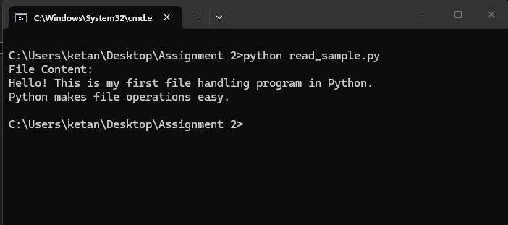
Explanation
- open() function is used with "r" mode to read a file.
- read() function reads the complete content.
- print() displays the file content on the screen.

